**Chapter 1: Interactive Schedul-**

**ing**

**Purpose and Scope of Interactive Scheduling** Schedule changes occur during the work day. Keeping the schedule up to date is essen- tial to maintain its quality and cost effectiveness. To accomplish this, Optibus OnSched-

ule™ provides an interactive manual editing facility. In addition, the manual editing

facility enables you to fine-tune the schedule.

This chapter shows you how to open elements in the Gantts for editing and make changes using their information boxes. Most manual editing will be on the Drivers Gantt. Edits to the Vehicles Gantt are limited. You can only reschedule a trip in the Vehicles Gantt for a Vehicles-only schedule.

What follows will be based on editing the Drivers Gantt for a full schedule. At the end of the chapter there is a short section on editing the Vehicles Gantt elements for a

Vehicles-only schedule.

You can test your edits one at a time. At any point you can save or discard your changes. The following editing actions available that can be used alone or in combination:

*Table 1-1: Interactive Editing Functions for a full schedule*

|  |  |  |  |  |
| --- | --- | --- | --- | --- |
| **Function** | **Drivers** | | **Vehicles** | |
| **Available** | **Reference in Drivers Gantt**  **Interactive Editing** | **Available** | **Reference in Vehicles**  **Gantt Interactive Editing** |
| Move a trip to another Duty | Yes | **Move a trip to another**  **Duty** | N/A |  |
| Changing trip times | Yes | **Changing trip times** | Yes | **Changing trip times** |
| Delete a trip | Yes | **Delete a trip** | Yes | **Delete a trip** |
| Change a depot pull in \out | Yes |  | N/A |  |
| Replace a taxi with a deadhead | Yes | **Switch between Taxi and**  **Deadhead elements** | N/A |  |
| Add new custom elements | Yes | **Add new elements** | No |  |
| Block functions |  | | | |
| Block ID | Yes | **Change Duty ID** | Yes, | **Change Vehicle ID** |
| Start/End stops | Yes | **Change duty Start/End stops** | No |  |
| Vehicle type | N/A |  | Yes | **Change Vehicle Type** |
| Move a duty up or down | Yes | **Move a driver duty up or down** | Yes | **Move a vehicle duty up or down** |
|  |  | | | |
|  |  | **De-assign a trip to the editing stack** | No |  |
|  |  | **Restore a trip to the edit- ing stack** | No |  |
| Create a new trip | **Using Add Trip** | | | |

*Table 1-2: Interactive Editing Functions for a vehicles-only schedule*

|  |  |
| --- | --- |
| **Function** | **Reference in Using a Vehicles-only Schedule** |
| Move a trip to another vehicle | **Move a trip to another vehicle** |
| Changing trip times | **Changing trip times** |
| Delete a trip | **Delete a trip or deadhead** |
| Change a depot pull in\out |  |
|  |  |
| Block functions |  |
| Block ID | **Change Vehicle ID** |
| Vehicle type | **Change Vehicle Type** |
| Move a vehicle up or down | **Move a vehicle up or down** |
| Create a new trip | **Using Add Trip** |

**Preparing for an Interactive Editing Session**

At the top of the Gantt display, you will have noticed that there is an option to save or dis- card your changes, for example after setting preferences or running an optimization:



The same applies to manual editing. Until you feel comfortable using manual editing, we suggest that you start by backing up your existing schedule using **Save As** from the Context Menu.



To enter Manual Editing mode, click the Manual Edit button in the top toolbar. An editing area (in the red box) called the **stack**, opens above the regular Gantt:

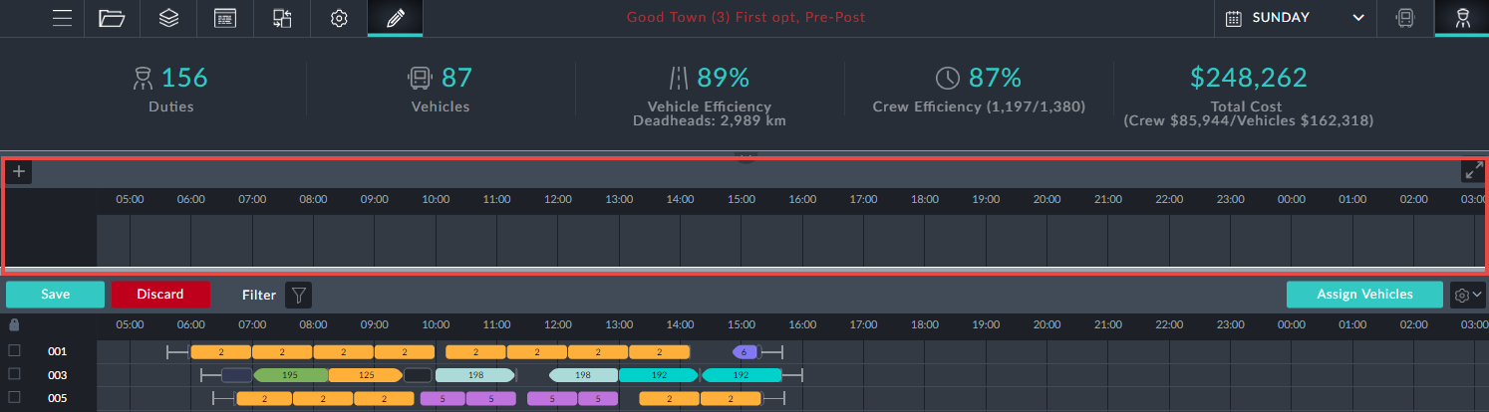

**Drivers Gantt Interactive Editing**

**What can be edited**

Trips can have their start/end times edited or be removed completely



Depot pull in destination or depot pull out origin can be changed

Taxi can be added / removed / replaced by a deadhead

Block information boxes offer editable fields: Driver ID and start/end locations for the

duty.

**Move a trip**

It is required to move the red-boxed trip in duty 201 in the Drivers Gantt to a different duty:

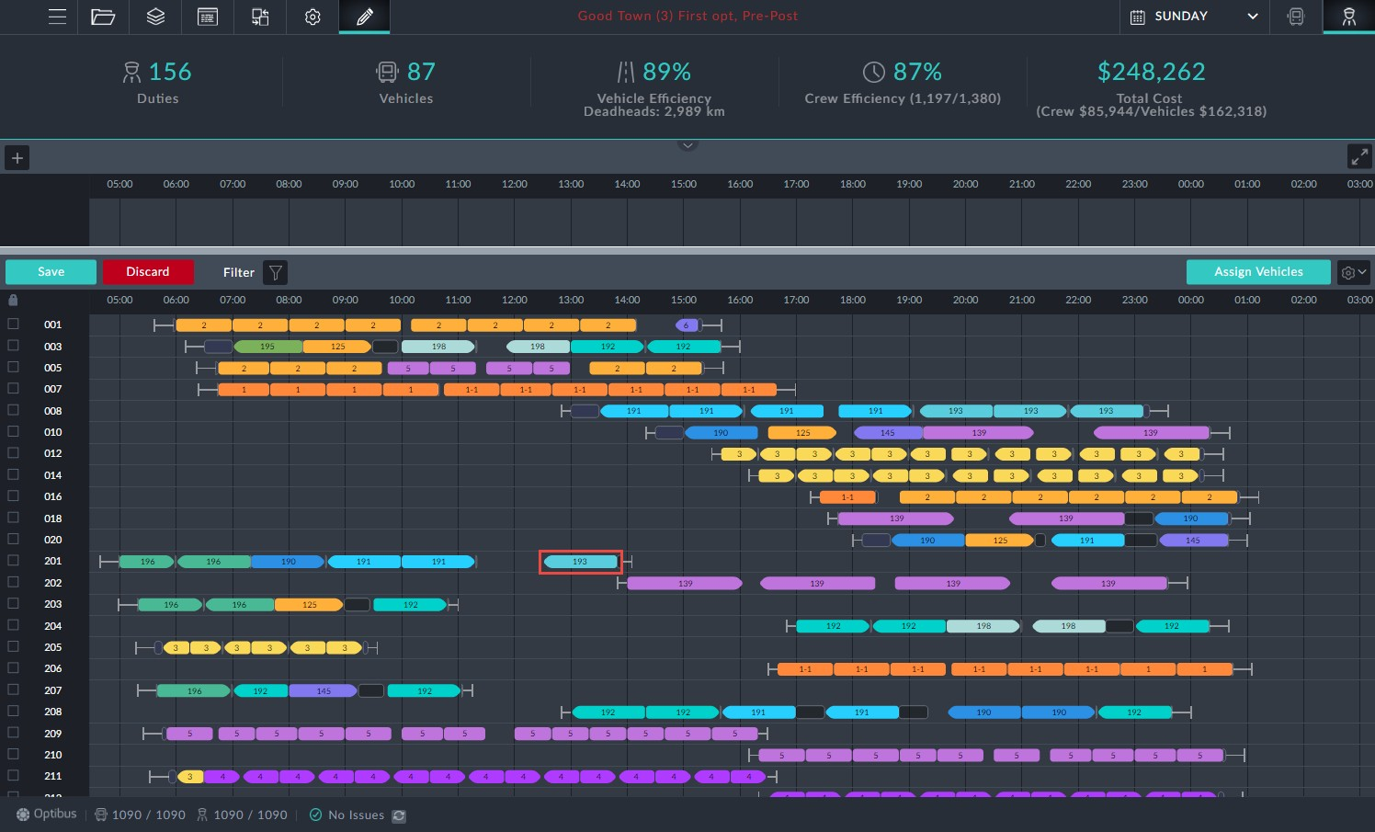

*Figure 1-1: Drivers Gantt prepared for manual editing*

Ø**To move a trip to another Duty:**

1. Enter Editing Mode as shown.

2. Double click the trip to be moved.

A shaded area including possible trip slots is displayed.

The system automatically recommends all possible options for relocation of the

trip. There are two indications for each option:

A blue frame indicates that preferences are honored.

A red frame for an option indicates a violation of preferences. Inside the frame is a quality rating: 1 to 5 stars.

There is also an option to move the trip to the stack…. The number of trips that are not assigned to any duty and are located in the stack can be found next to the validation error by subtracting the assigned trips from the total number of trips.

3. At duty 10 there is a slot with four stars in a red border. Click it to opens its

information box:

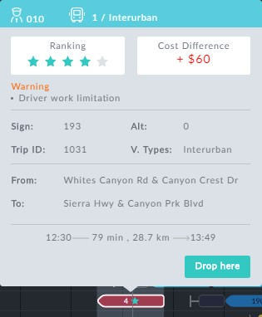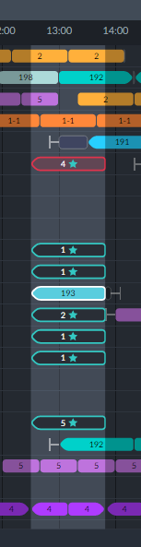

*Figure 1-2: Left: Eligible slots; Right: Problematic red bordered slot: Work limitation violation*

4. At the bottom of the eligible slots, there is one at duty 207 with a blue border and five stars. it is sufficient to double click it to move the trip.

Here is part of the changed Drivers Gantt showing the moved trip, shown in the red box. Notice also the new generated sign-off immediately after the trip.

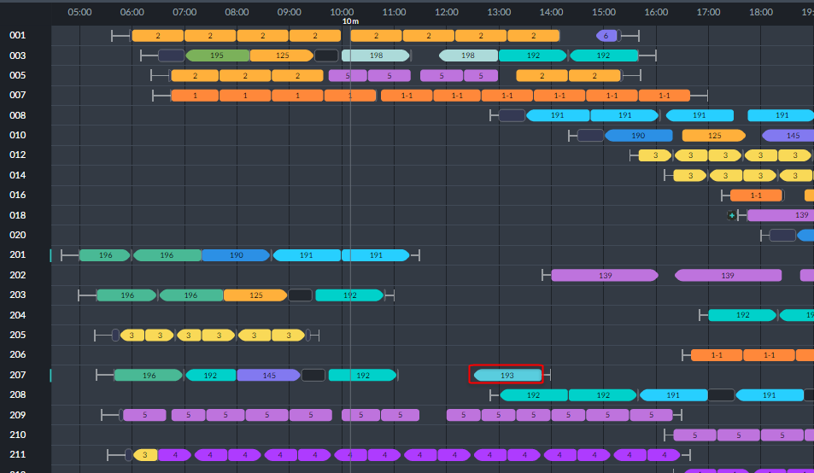

The re-assignment affects the Vehicles schedule: In the Vehicles Gantt, vehicle 3, (which

is slotted to do the new trip) and also vehicle 1:

(and add a reference to the “assign vehicles” section)

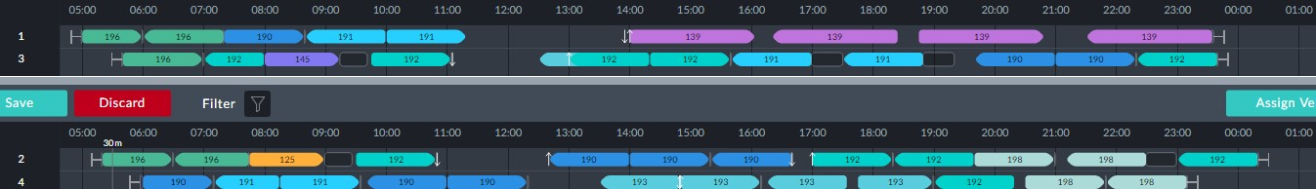

In the end vehicle 3 does not do it. To see the actual result, click the **Assign Vehicles** but- ton. We will not display it here. The new trip has been assigned to vehicle 88. An exam- ination of the KPIs shows that the change has increased the vehicles count from 87 to 89.



For advanced use of **Assign Vehicles**, see **Completing the Edit Session**.

**Changing trip times**

To illustrate the procedure we will use duty 201 from **Figure 1-1**. The first duty for the day is a trip on sign 196. Here is its information box:

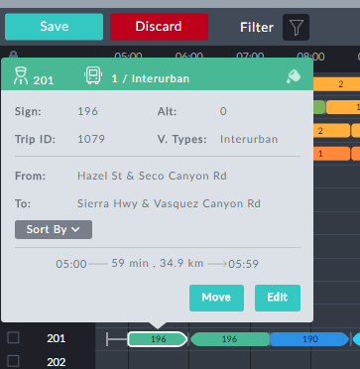

Ø**To change the trip times:**

1. Click **Edit** in the information box:

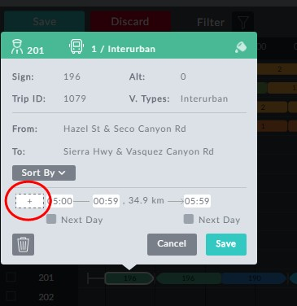

*Figure 1-3: Information box ready for editing*

All of the time fields are open for editing. In addition, the left hand time field (red circle) allows us to add time to the beginning of the trip by entering an earlier time than the shown trip start time.

2. By default it sets itself to the start time of 05:00. Enter 04:53.

3. Also extend the trip length by 5 min by increasing the shown length of 59 min to 64 min:

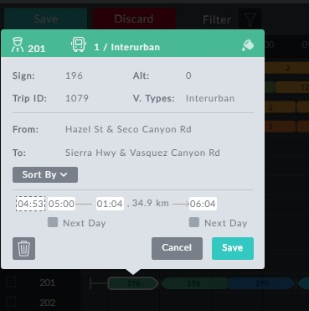

We could have changed the trip end time to 06:04 and the trip duration

would have been updated.

4. Click **Save**.



In **Figure 1-3** below, observe that changed trip element has a black dot indic-

ating that it has been manually changed. Further, the duty block 201 is preceded by a blue change-bar.

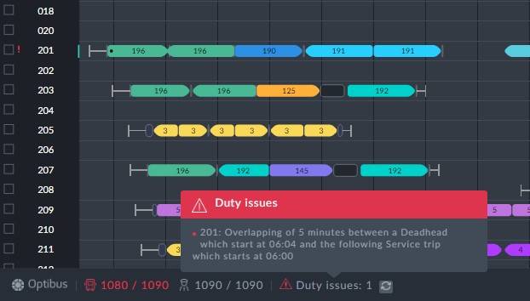

*Figure 1-4: Duty Issue caused by the edit*

Clicking the **Assign Vehicles** button commits the change to the loaded schedule (without saving it).

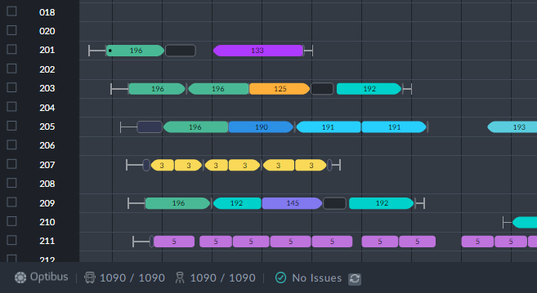

**Delete a trip**

***Deleting a Trip***

We will use the same example as in **Changing trip times** (the red-boxed trip in duty

201).

Ø**To delete a trip:**

1. In **Figure 1-3** above, click the  button.

2. Click **Save**. You are asked to confirm:

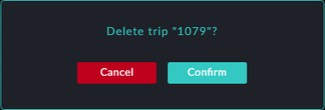

3. Click **Confirm** to accept the deletion.

The trip is deleted from the Drivers Gantt:

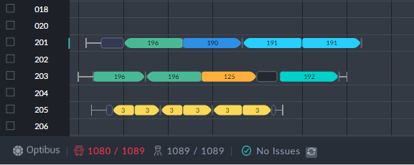

Complete the change by clicking **Assign Vehicles**.

***Changing a depot pull in/out***

You can change a depot pull in destination or depot pull out origin in a beginning /ending of a duty or in the beginning or ending of split break.

To do so, follow these steps (do it at both beginning and ending of the duty\split)

1. Delete the depot pull in/out
2. Add a new depot pull in \out
3. Assign vehicles

**Add\remove a taxi**

A taxi at the beginning/ending of a duty or a split break can be added or removed.

**Replace a Taxi with a Deadhead**

Taxi in the beginning\ending of a split break can be replaced with a deadhead, and sometimes also a taxi in the beginning/ending of a duty can be replaced.

to do so:

1. Enter the taxi tooltip
2. Press edit and change the taxi to a deadhead (if it is a taxi in a split break and there is no vehicle changeover, need to replace both taxis at the beginning and ending of the split)
3. Assign vehicles (if the taxi cannot be replaced with a deadhead the assign vehicles will re-add a taxi)

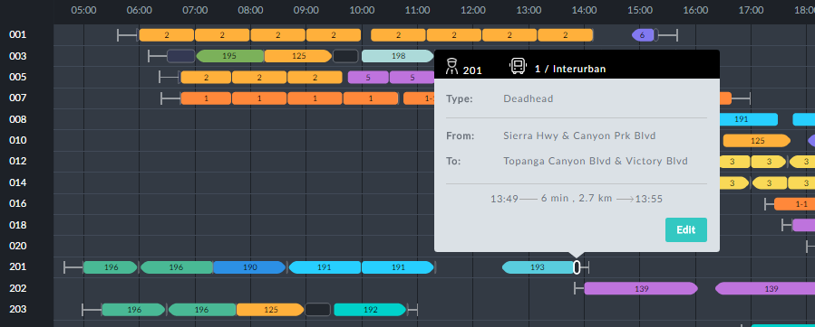

Open it for editing, and click the **Type** field:

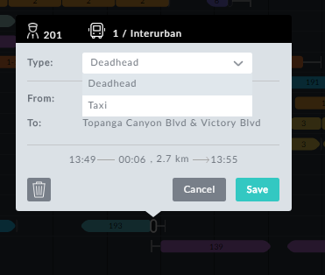

Change it to Taxi and save:

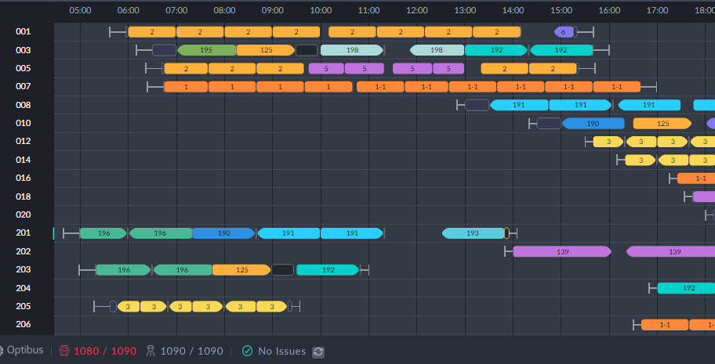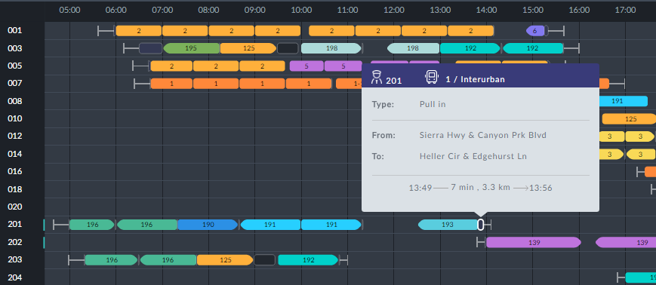

**Add new element**

***Adding a new custom element***

You can add a new deadhead or taxi to the beginning and end of a duty. You can add a Taxi to either start or end of a split break. Eligible locations in the Drivers Gantt can be seen by hovering the mouse cursor at the beginning or end of a duty, a deadhead or a split. You will see a small button. Clicking it opens an editable window as in the following example:

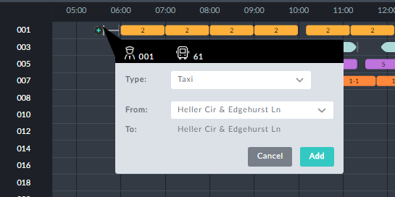

The **From:** field opens a drop-down list of eligible origin stops. The **Type:** field also offers a drop-down list:

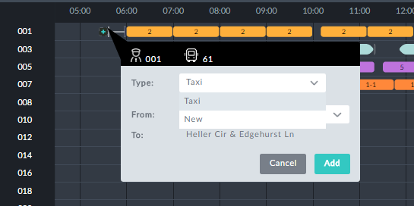

*Figure 1-5: Choosing the "Taxi Type"*

You can either choose Taxi (or any other predefined available type) or create a new "Taxi Type" of your own. For now, leave it at Taxi and click **Add**. Apart from a change-bar, t. Click **Assign Vehicles**. Nothing happens. Oops! TBD

***Adding a new element and a new type***

Continuing with **Figure 1-5**, we will choose New:

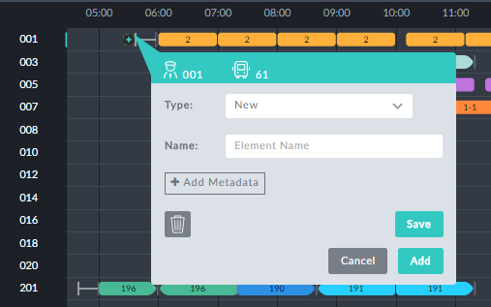

In the **Name:** field we enter a new type, Shuttle and then **Save**.



You can use the **Add** button to add more types. The one chosen will be

the last element name you enter.

**Adding Metadata** is an expert mode function for use in conjunction with

Optibus Professional Services

Here is the outcome:

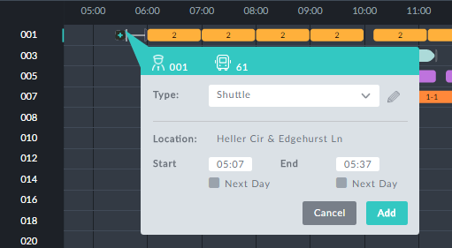

You can edit the Start and End times. We will leave as is and click **Add**. The Drivers Gantt changes as follows:

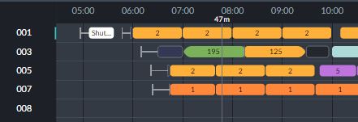

To confirm your edit, click the Shuttle information box:

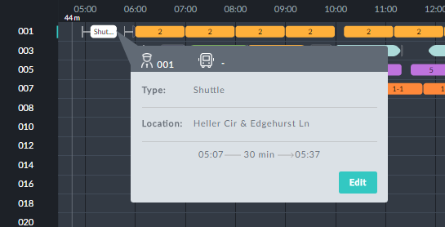

Notice also that the **Sign on** element has been moved back before the shuttle:

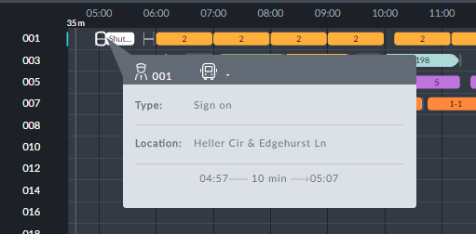

Complete the new assignment by clicking **Assign Vehicles**.

***-***

Again using **Figure 1-5** and driver 201, click the gap between the last two trips, 191 and

193:



We are presented with an edit window:

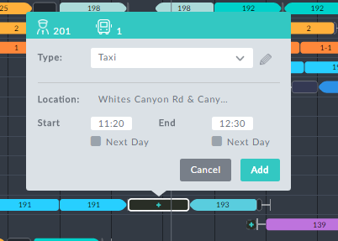

We can choose between Taxi and our own types:

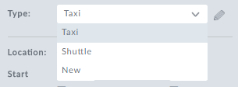

Click the **Assign Vehicles** button to confirm the edit.

**Block level editing**

Using **Figure 1-5** and driver 201, click the block to display its information box:

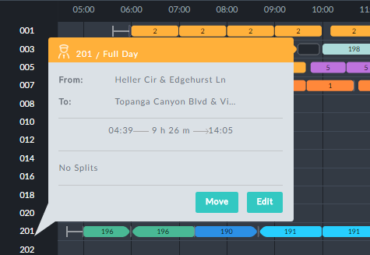

*Figure 1-6: Editing or moving a Driver block*

Click **Edit** to open it for editing:

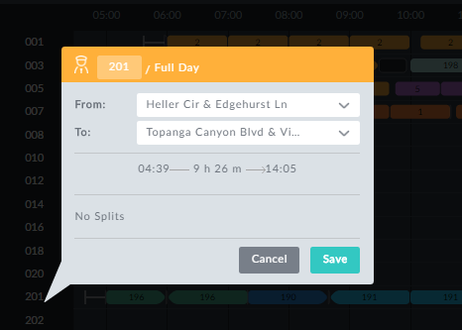

***Change Duty ID***

In **Figure 1-6**, change the driver ID 20 2010 and save:

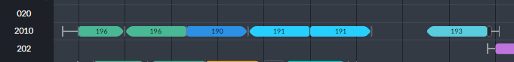

***Set Start/End stops***

The **From**: and **To:** fields are drop-down lists of eligible duty start and finish stops.



***Move a block up or down***

In **Figure 1-6** click **Move**. A horizontal blue cursor line is displayed:

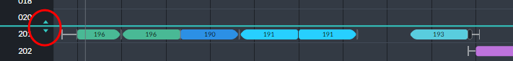

Choose your desired location and place the duty there by double clicking on the blue cursor.

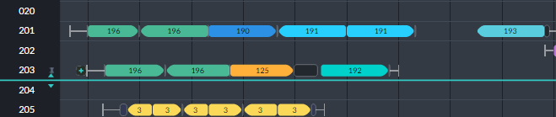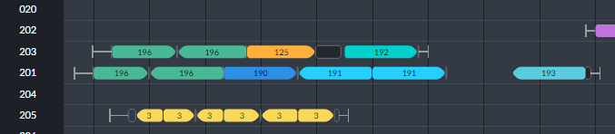

**Edit Stack functions**

***De-assign a trip to the editing stack***

In the left side of **Figure 1-2**, double clicking the stack will re-assign the trip and move it to the stack:

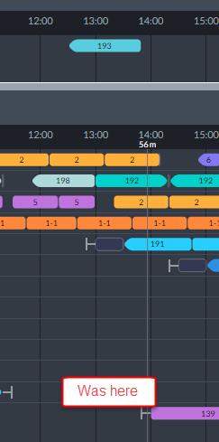

It is instructive to view the Vehicles stack area:



Vehicle 1 that originally did the trip we de-assigned is shown without it. A "temporary" vehicle (v_88) is assigned to the trip.

***Restore a trip to the editing stack***

To restore the trip in the previous example, it is sufficient to double click it and then click the target slot in the eligible trip slots:

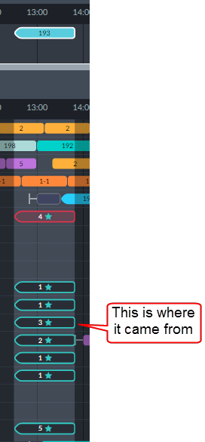

Click **Assign Vehicles** to commit your edits.

**Vehicles Gantt Interactive Editing**

**What can be edited**

Trips can have their start/end times edited or be removed completely



**Change trip times**

The method is the same as for Driver trip elements.

**Delete a trip**

Deleting a trip is the same as for Driver trip elements.

**Block level editing**

In the Vehicles Gantt, clicking a Vehicle block number opens the bock information box:

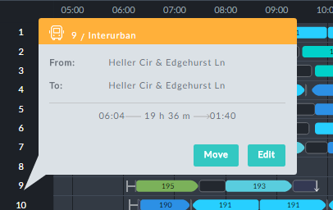

To open it for editing, click **Edit**:

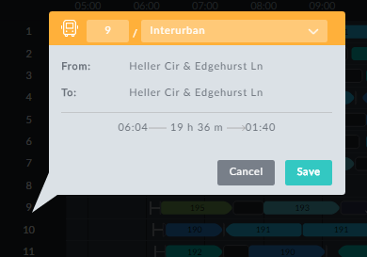

*Figure 1-8: Editing Vehicle block information box*

***Change Vehicle ID***

In **Figure 1-8**, you can change the Vehicle ID. You will be prevented from entering an ID

already in use. In this example, you could enter something like 9a.

***Change Vehicle Type***

Here you are offered a choice of Vehicle Types from those defined in the schedule.

***Move a block up or down***

This feature works the same way as it does for Driver blocks.

It open up the following dialog:

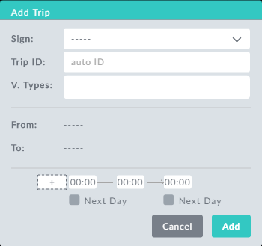

*Figure 1-9: Add Trip dialog*

To demonstrate the use of this feature, we start out with a segment of the Vehicles Gantt from the schedule we have used throughout this manual:

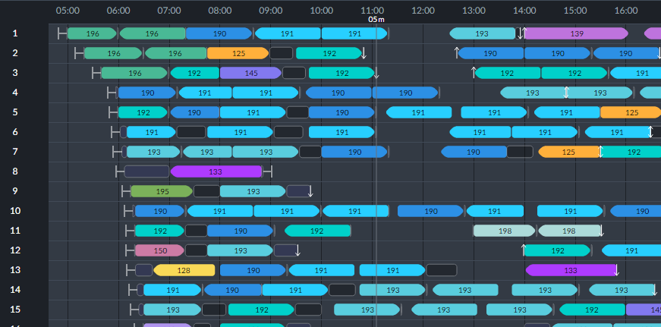

We will add an inter-urban trip for sign 192 at 10:35. Here is the filled out window of

**Figure 1-2**:

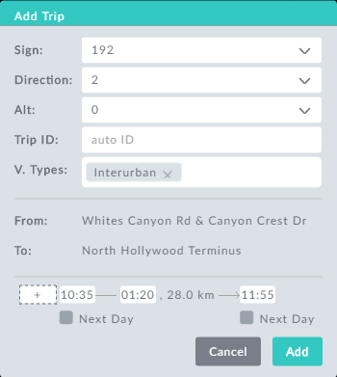

Here we set the direction, start time and trip duration. On clicking **Add**, we see the new trip in the editing stack ready for assignment:

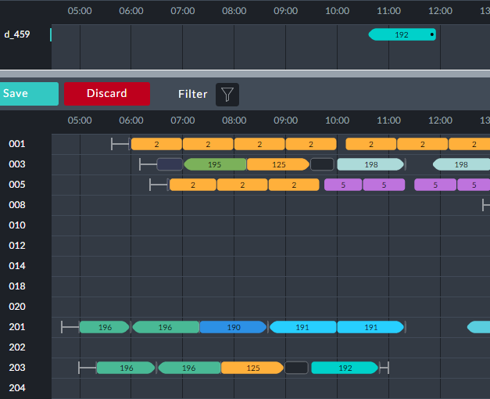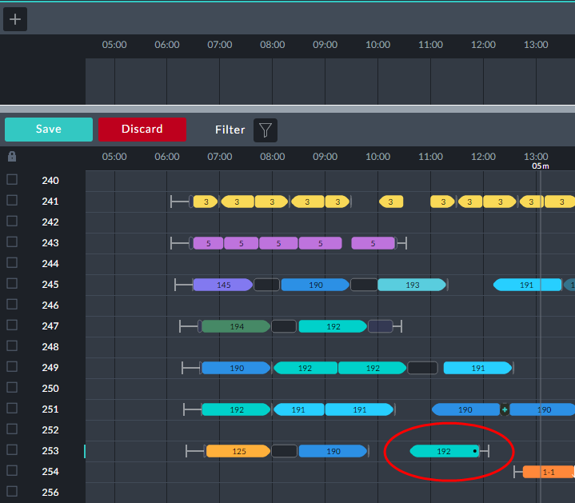

**Using a Vehicles-only Schedule**

**What can and cannot be edited**

Trips can have their start/end times edited or be removed completely



Depot pull in\out can be changed

Block information boxes offer editable fields: Vehicle ID and type



**Move a trip to another Vehicle**

It is required to move the red-boxed trip in vehicle 5 in the Vehicles Gantt to a different vehicle:

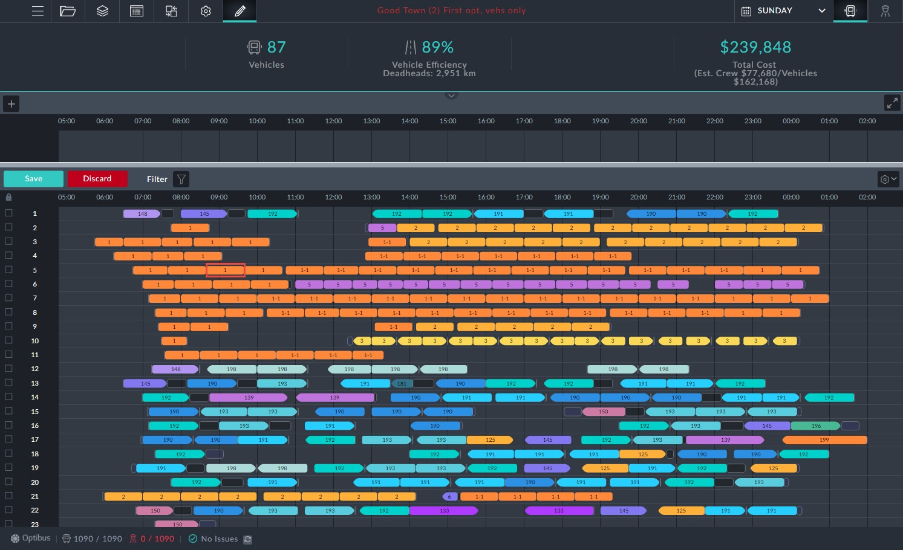

*Figure 1-10: Vehicles Gantt prepared for manual editing*

To do it, we must first be in manual editing mode as shown. Double clicking the trip shows a shaded area including possible trip slots as it did for moving trips in the Drivers Gantt. The system automatically recommends all possible options for relocation of the trip. The procedure for moving the trip here, is the same as in **Move a trip to another Duty**. We will not repeat the details here.

**Changing trip times**

Click a trip element for editing.

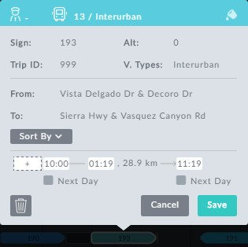

*Figure 1-11: Editing a vehicle through its information box*

Changing trip start/end times works the same way as it does for Drivers.

**Delete a trip**

***Deleting aTrip***

We will use the same example as in **Changing trip times**. In **Figure 1-11** above, we click the button and then **Save**. You are asked to confirm the deletion.



***Change a depot pull in\out***

**Block level editing**

In the Vehicles Gantt, clicking a Vehicle block number opens the box information box:



To open it for editing, click **Edit**:



*Figure 1-12: Editing Vehicle block information box*

***Change Vehicle ID***

In **Figure 1-8**, you can change the Vehicle ID. You will be prevented from entering an ID

already in use. In this example, you could enter something like 9a.

***Change Vehicle Type***

Here you are offered a choice of Vehicle Types from those defined in the schedule.

***Move a block up or down***

This feature works the same way as it does for Driver blocks. The same priority con- sideration obtains here as well: The relative location of a Vehicle block in the Gantt sets its relative priority during optimization.

**Completing the Edit Session**

**Using the Assign Vehicles Button**

To complete the session you must click the button. An advanced usage is available by opening button's context menu:

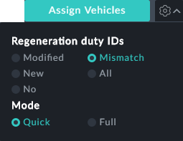

**Regeneration duty IDs**

If you have moved trips or added new elements you will have to regenerate some or all of the duty IDs. You can choose between the following:

Modified



New No Mismatch All



**Mode:**

Quick: Full:

